Choose one book and be prepared for a reading assessment
The Fever King by Victoria Lee
In the former United States, sixteen-year-old Noam Álvaro wakes up in a hospital bed, the sole survivor of the viral magic that killed his family and made him a technopath. His ability to control technology attracts the attention of the minister of defense and thrusts him into the magical elite of the nation of Carolinia.

Shout by Laurie Halse- Anderson
In free verse, Anderson shares reflections, rants, and calls to action woven between deeply personal stories from her life that she's never written about before. Searing and soul-searching, this important memoir is a denouncement of our society's failures and a love letter to all the people with the courage to say #MeToo and #TimesUp, whether aloud, online, or only in their own hearts. SHOUT speaks truth to power in a loud, clear voice-- and once you hear it, it is impossible to ignore.
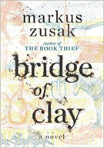 | Bridge of Clay by Marcus Zusak  The breathtaking story of five brothers who bring each other up in a world run by their own rules. As the Dunbar boys love and fight and learn to reckon with the adult world, they discover the moving secret behind their father’s disappearance.
On the Come Up- Angie Thomas
Sixteen-year-old Bri wants to be one of the greatest rappers of all time. Or at least win her first battle. As the daughter of an underground hip hop legend who died right before he hit big, Bri’s got massive shoes to fill.
But it’s hard to get your come up when you’re labeled a hoodlum at school, and your fridge at home is empty after your mom loses her job. So Bri pours her anger and frustration into her first song, which goes viral…for all the wrong reasons.

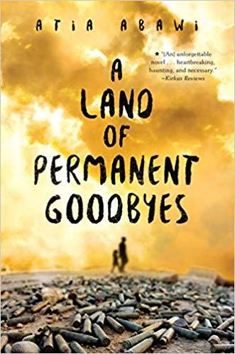 | A Land of Permanent Goodbyes by Atia Abawi  In a country ripped apart by war, Tareq lives with his big and loving family . . . until the bombs strike. His city is in ruins. His life is destroyed.  And those who have survived are left to figure out their uncertain future. Tareq's family knows that to continue to stay alive, they must leave. As they travel as refugees from Syria to Turkey to Greece, facing danger at every turn, Tareq must find the resilience and courage to complete his harrowing journey.
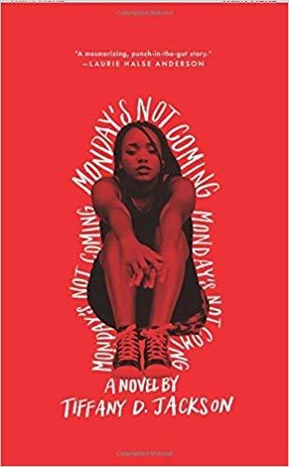 | Monday’s not Coming by Tiffany D. Jackson  Monday Charles is missing, and only Claudia seems to notice. Claudia and Monday have always been inseparable—more sisters than friends. So when Monday doesn’t turn up for the first day of school, Claudia’s worried.  When she doesn’t show for the second day, or second week, Claudia knows that something is wrong. Monday wouldn’t just leave her to endure tests and bullies alone. Not after last year’s rumors and not with her grades on the line. Now Claudia needs her best—and only—friend more than ever. But Monday’s mother refuses to give Claudia a straight answer, and Monday’s sister April is even less help.
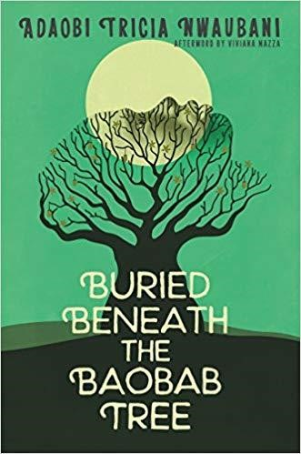 | Buried Beneath The Baobab Tree by Adaobi Tricia Nwabani A new pair of shoes, a university degree, a husband—these are the things that a girl dreams of in a Nigerian village. And with a government scholarship right around the corner, everyone can see that these dreams aren’t too far out of reach.But the girl’s dreams turn to nightmares when her village is attacked by Boko Haram, a terrorist group, in the middle of the night. Kidnapped, she is taken with other girls and women into the forest where she is forced to follow her captors’ radical beliefs and watch as her best friend slowly accepts everything she’s been told.
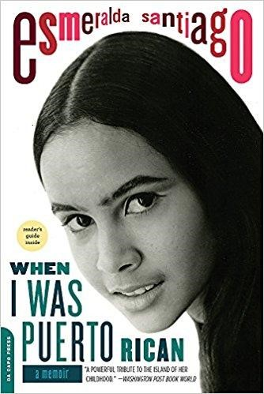 | When I was Puerto Rican by Esmeralda Santiago  Esmeralda Santiago learned the proper way to eat a guava, the sound of tree frogs, the taste of morcilla, and the formula for ushering a dead baby's soul to heaven. But when her mother, Mami, a force of nature, takes off to New York with her seven, soon to be eleven children, Esmeralda, the oldest, must learn new rules, a new language, and eventually a new identity.
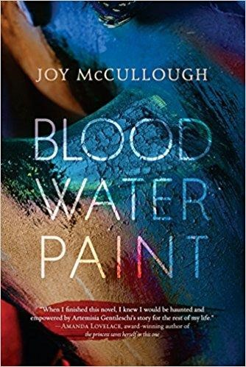 | Blood Water Paint by Joy Mcullough  Her mother died when she was twelve, and suddenly Artemisia Gentileschi had a stark choice: a life as a nun in a convent or a life grinding pigment for her father's paint.  She chose paint.  By the time she was seventeen, Artemisia did more than grind pigment. She was one of Rome's most talented painters, even if no one knew her name. But Rome in 1610 was a city where men took what they wanted from women, and in the aftermath of rape Artemisia faced another terrible choice: a life of silence or a life of truth, no matter the cost.
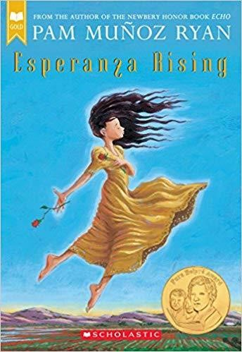 | Esperanza Rising by Pam Munoz Ryan  Esperanza thought she'd always live a privileged life on her family's ranch in Mexico. She'd always have fancy dresses, a beautiful home filled with servants, and Mama, Papa, and Abuelita to care for her. But a sudden tragedy forces Esperanza and Mama to flee to California and settle in a Mexican farm labor camp. Esperanza isn't ready for the hard work, financial struggles brought on by the Great Depression, or lack of acceptance she now faces. When Mama gets sick and a strike for better working conditions threatens to uproot their new life, Esperanza must find a way to rise above her difficult circumstances-because Mama's life, and her own, depend on it.

